**STUDY ON SURFACE ROUGHNESS**

Date of Experiment – 06/03/17

Instructor – Prof. B. Bhattacharya

Submission Date – 08/03/17

Group number - A3

Arvind Kumar Prasad 150141

Ashish Kumar Yadav 150148

Asim Katakwar 150159

Atul Bimbrahw 150162

Avinash Kumar 150169

Ayush Singh 150177

Bhanupratap Niranjan 150182

**Aim**: To study on roughness of surfaces.

**Introduction (Terminology):**

**Surface roughness** is a measure of the texture of a surface. It is quantified by the vertical deviations of a real surface from its ideal form. If these deviations are great, the surface is rough, if they are small, the surface is smooth. Roughness is typically considered to be the high-frequency, short-wavelength component of a measured surface. In practice, it is often necessary to know both the amplitude and frequency to ensure that a surface is fit for purpose.

Sample Length is the benchmark’s length for evaluating the surface roughness.

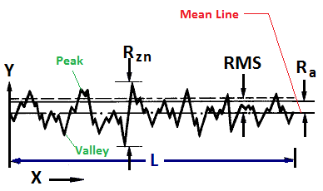

Evaluation Length is the necessary length for evaluating the roughness profile. It may include one or more sampling lengths.

**Ra**:  Arithmetical Mean Deviation of the Profile is arithmetical mean value of the deviation of the profile within sampling length.

**Rz:** The maximum height of irregularities is the distance between maximum depth of profile peaks and maximum depth of profile valley within the sampling length.

**Rq:** Root-mean-square Deviation of Profile .It is the square root of the arithmetic mean of the square of the profile deviation (Yi) from mean within sampling length.

**Rt:** Total Peak to Valley Height.

Rt is the sum of the height of highest peak and depth of the deepest valley over the evaluation length.

**QualiSurf I** portable surface roughness tester is a pocket-sized economically priced instrument for measuring surface texture conforming to traceable standards. It can be used in any position, horizontal, vertical or anywhere in between.

The large OLED display shows four (4) roughness parameters Ra, Rz, Rq and Rt at the touch of a button, combined with the selectable cut-off length. External calibration of roughness values is possible by means of a special CAL button, which makes adjustment of this instrument very easy. A beep signal informs the user of each individual measurement status when ready.

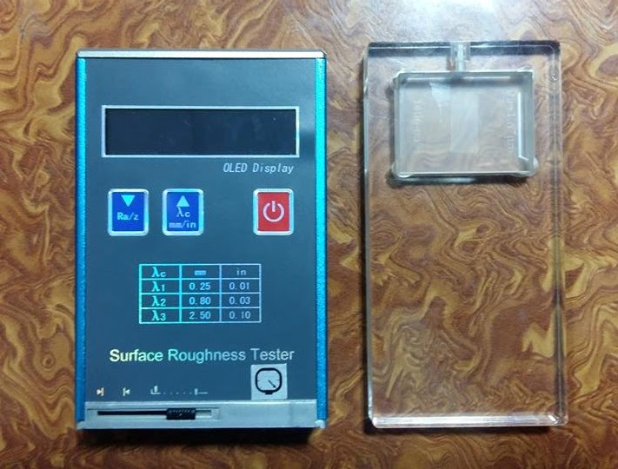

**Technical Specification for Portable Surface Roughness Tester - QualiSurf I**

|  |  |
| --- | --- |
| **Parameters** | Ra, Rz, Rq and Rt |
| **Measuring Range** | Ra: 0.05 ~10.0 µm Rz: 0.1 ~ 50.0 µm |
| **Cut-off Length** | 0.25, 0.8 and 2.5 mm (0.001”, 0.03”, 0.01”) |
| **Tracing Length** | 6 mm |
| **Measuring Lengths** | 1.25, 4.0 and 5.0 mm |
| **Measuring Unit** | Both metric & imperial modes |
| **Accuracy** | +/- 10% of actual value |
| **Contact force on probe** | <1.8ozf (<50gf) |
| **Static measuring force of sensor stylus** | <0.06ozf (<1.6gf) |
| **Dimensions** | 125 x 73 x 26 mm (4.9 x 2.8 x 1.0 in) |
| **Weight** | 200 g (0.4 lbs) |
| **Operating Temperature** | 0° ~ 40° C (32 – 104 degrees F) |
| **Power Supply** | Rechargeable battery with indication of battery condition mains |
| **Power Source** | AC plug with USB cable, 110V-240V |

**Working Principle:**

When the pickup driven by a driver is making a linear uniform motion along the test surface, the contact stylus in perpendicular with the work surface is moving up and down on the work surface. Its motion is converted into electrical signals, which are amplified, filtered and transformed into digital signal through A/D (analogue to digital converter). The signals are then processed by the DSP (digital signal processor) into Ra and Rz values before displayed on the screen.

**Specimen provided in lab:**

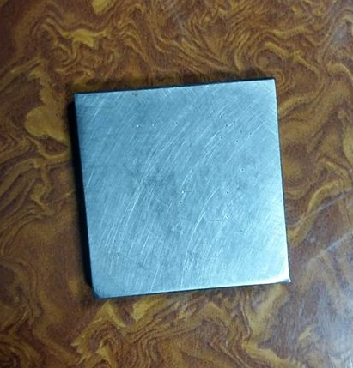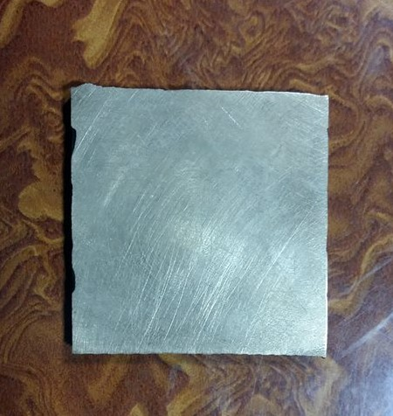

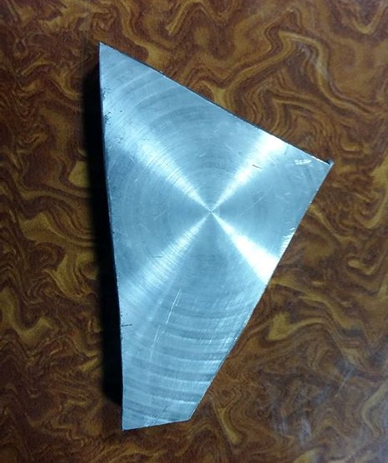Steel Brass  
  
  
  
Aluminium

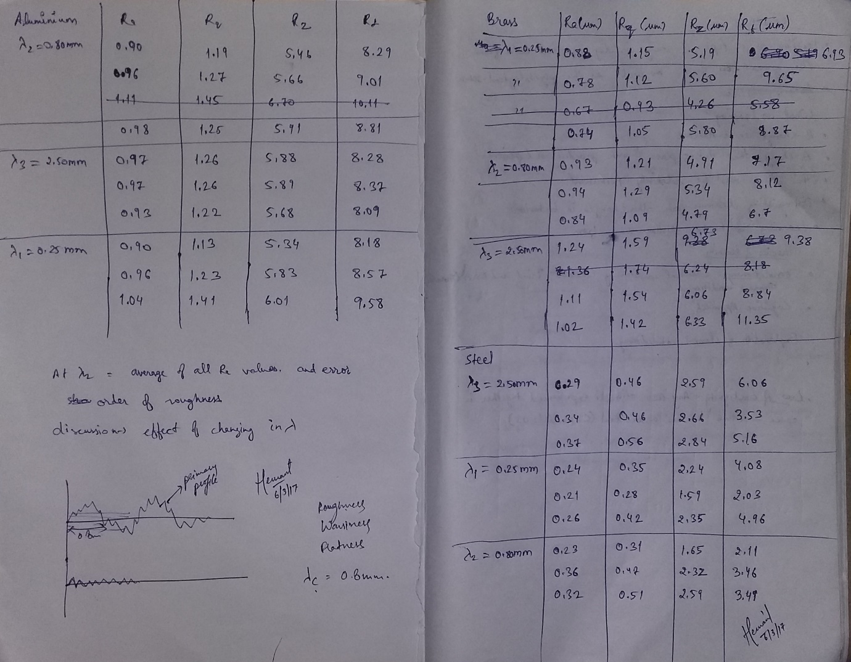

**Readings:**

𝛌1 = 0.25 mm, 𝛌2 = 0.80 mm and 𝛌3 =2.50 mm.

  (All readings are in µm)

1. **Brass**

|  |  |  |  |  |
| --- | --- | --- | --- | --- |
|  | **Ra** | **Rq** | **Rz** | **Rt** |
| **𝛌1** | **0.88**  **0.78**  **0.74** | **1.15**  **1.12**  **1.05** | **5.19**  **5.60**  **5.80** | **6.93**  **9.65**  **8.87** |
| **𝛌2** | **0.93**  **0.94**  **0.84** | **1.21**  **1.29**  **1.09** | **4.91**  **5.34**  **4.79** | **7.17**  **8.12**  **6.70** |
| **𝛌3** | **1.24**  **1.11**  **1.02** | **1.59**  **1.54**  **1.42** | **6.73**  **6.06**  **6.33** | **9.38**  **8.84**  **11.35** |

1. Steel

|  |  |  |  |  |
| --- | --- | --- | --- | --- |
|  | **Ra** | **Rq** | **Rz** | **Rt** |
| **𝛌1** | **0.24**  **0.34**  **0.37** | **0.35**  **0.28**  **0.42** | **2.24**  **1.59**  **2.35** | **4.08**  **2.03**  **4.96** |
| **𝛌2** | **0.23**  **0.36**  **0.32** | **0.31**  **0.47**  **0.51** | **1.65**  **2.32**  **2.59** | **2.11**  **3.46**  **3.49** |
| **𝛌3** | **0.29**  **0.34**  **0.37** | **0.46**  **0.46**  **0.56** | **2.59**  **2.66**  **2.84** | **6.06**  **3.53**  **5.16** |

1. **Aluminium**

|  |  |  |  |  |
| --- | --- | --- | --- | --- |
|  | **Ra** | **Rq** | **Rz** | **Rt** |
| **𝛌1** | **0.90**  **0.96**  **1.04** | **1.13**  **1.23**  **1.41** | **5.34**  **5.83**  **6.01** | **8.18**  **8.57**  **9.58** |
| **𝛌2** | **0.90**  **0.96**  **0.98** | **1.19**  **1.27**  **1.25** | **5.46**  **5.66**  **5.91** | **8.29**  **9.01**  **8.81** |
| **𝛌3** | **0.97**  **0.97**  **0.93** | **1.26**  **1.26**  **1.22** | **5.88**  **5.89**  **5.68** | **8.28**  **8.37**  **8.09** |

**Calculations:**

Average values for 𝛌2 = 0.8mm:

For Brass, Ra = 0.90

For Steel, Ra = 0.30

For Aluminium, Ra = 0.95

**Error Analysis (Standard Deviation):**

Calculated standard deviation for Brass (for 𝛌2 = 0.8mm):

Ra = 0.045 µm

Calculated standard deviation for Steel (for 𝛌2 = 0.8mm):

Ra = 0.054 µm

Calculated standard deviation Aluminium (for 𝛌2 = 0.8mm):

Ra = 0.034 µm

**(**We are getting some values different from rest of the values, because the sample we took do not have uniform properties throughout its surface. The average roughness (Ra) is by far the most commonly used parameter in surface finish.)

**Conclusion/Result:**

Order of roughness is: Aluminium > Brass > Steel.

**Discussion:**

As we can see from the readings that if we increase 𝛌, the values of roughness parameters increases.

For example, for Brass, average values of Ra increases from 0.80(for 𝛌1), 0.90(for 𝛌2) to 1.12(for 𝛌3).

**Precautions:**

1. During the pickup travelling, make sure the tester is on the measured surface stably so as to avoid its influence to the precision.
2. During the pickup return to starting position, the tester will not make any further operation.
3. If the readings are out of range, try auto-calibration. (Press and hold “start” button and turn on the unit.)

**REFERENCES-**

* <http://www.mitutoyo.com/wp-content/uploads/2012/11/1984_Surf_Roughness_PG.pdf>
* Qualitest User Manual
* [Degarmo, Black & Kohser 2003](https://en.wikipedia.org/wiki/Surface_finish" \l "CITEREFDegarmoBlackKohser2003), p. 223.